Name: | Muhammad Taha
CMS Id: | 518133

Lesson Set 3 | To demonstrate the use of arithmetic operators
Purpose | - To demonstrate the use of arithmetic operators  - To understand arithmetic operations using integer, float, double, etc.  - To become familiar with increment, and decrement operators.  - To understand prefix and postfix operators.  - To understand the difference between postfix and prefix operators.
Procedure | - Students should read the Pre-lab Reading assignment before coming to the lab.  - Students should complete the Pre-lab Writing assignment before coming to the lab.  - In the lab, students should complete Labs 3.1 through 3.4 in sequence. Your instructor will give further instructions as to grading and completion of the lab.  - Students should complete the set of lab tasks before the next lab and get them checked by their lab instructor.
 | Contents | Pre-requisites | Completion Time | Page Number
 | Pre-lab Reading Assignment | - | 20 min | 2
 | Pre-lab Writing Assignment | Pre-lab Reading | 10 min | 5
 | Lab 3
 | Lab 3.1  Working with arithmetic operators (Circle area & Circumference) | Pre-lab reading | 20 min | 6
 | Lab 3.2  Working with arithmetic operators (Area & Parameter of rectangle) | Understanding of operators.(Arithmetic and assignment operator) | 30 min | 6
 | Lab 3.3  Increment decrement with Postfix, Prefix | Understanding of operators.  (Prefix and postfix) | 20 min | 6
 | Lab 3.4  Increment decrement with Postfix, Prefix (identify difference) | Understanding operators. and  Lab 3.3 | 20 min | 7
 | Lab 3.5  Lab Task | Understanding operators, Lab3.1-3.4 | 60mins | 8

PRE-LAB READING ASSIGNMENT
Arithmetic Operators
Increment, Decrement (++,--)  Prefix, Postfix  Difference between Prefix and Postfix  Assignment operator along with postfix/prefix: | Programming has the traditional arithmetic operators:  Operator Symbol Form Operation  Addition + x + y x plus y  Subtraction - x - y x minus y  Multiplication * x * y x multiplied by y  Division / x / y x divided by y  Modulus (Remainder) % x % y The remainder of x divided by y  Integer division occurs when both the numerator and denominator of a divide operation are integers (or numbers stored in variables defined to be integers). The result is always an integer because the decimal part is truncated or “chopped” from the number. Thus 9/2 will give the answer 4 not 4.5! For this reason there are two division operations for integer numbers. The modulus operator, (%) used only with integers, gives the remainder of a division operation. 9/2 gives 4 while 9 % 2 gives 1 (the remainder of the division).  Example:  int count = 9;  int div = 2;  int remainder;  int quotient;  quotient = count / div; // quotient is assigned a 4  remainder = count % div; // remainder is assigned a 1  Example:  // This program prints to the screen the words:  // PI = 3.14  // Radius = 4  // Circumference = 25.12  #include <iostream>  using namespace std;  const double PI = 3.14;  int main()  {  float radius;  radius = 4.0;  cout << "PI = " << PI << endl;  cout << "Radius = " << radius << endl;  cout << "Circumference = " << 2 * PI * radius << endl;  return 0;  }  By now you should understand most of the statements.  Some expression can be shortened even more: the increase operator (++) and the decrease operator (--) increase or reduce by one the value stored in a variable. They are equivalent to +=1 and to -=1, respectively. Thus:  1 2 3 ++x; x+=1; x=x+1;  are all equivalent in its functionality; the three of them increase by one the value of x.  In the early C compilers, the three previous expressions may have produced different executable code depending on which one was used. Nowadays, this type of code optimization is generally performed automatically by the compiler, thus the three expressions should produce exactly the same executable code.  A peculiarity of this operator is that it can be used both as a prefix and as a suffix. That means that it can be written either before the variable name (++x) or after it (x++).  Although in simple expressions like x++ or ++x, both have exactly the same meaning; in other expressions in which the result of the increment or decrement operation is evaluated, they may have an important difference in their meaning: In the case that the increase operator is used as a prefix (++x) of the value, the expression evaluates to the final value of x, once it is already increased.  On the other hand, in case that it is used as a suffix (x++), the value is also increased, but the expression evaluates to the value that x had before being increased. Notice the difference:  Example 1 Example 2  x = 3; y = ++x; // x contains 4, y contains 4 x = 3; y = x++; // x contains 4, y contains 3  In Example 1, the value assigned to y is the value of x after being increased. While in Example 2, it is the value x had before being increased.  For “prefix” the statement y=++x contains two operators ++ and =. It works in following order:  - It increments the value of x by 1.  - It assigns the value of x to y.  For “postfix” the statement y=x++ contains two operators ++ and =. It works in following order:  - It assigns the value of x to y.  - It increments the value of x by 1.  If the increment/decrement is done along with the assignment in the same line of code then postfix and prefix will work differently.  On the other hand, if the increment/decrement is done before and separately and the assignment of the new value is done later i.e. in the next line of code then the results of prefix and postfix will be the same. Notice the difference:  Example 1 Example 2 Example 3 Example 4  x = 3; ++x; y=x; //x contains 4, y contains 4 x = 3; x++; y=x // x contains 4, y contains 4 x = 3; y=++x; //x contains 4, y contains 4 x = 3; y=x++; //x contains 4, y contains 3  In Example 1, the value of x is increased with prefix increment and assigned later in the next line. While in Example 2, the value of x is increased with a postfix increment and assigned later in the next line. But both have the same results because a new value of x is stored and when assigned to y, y will have a new value of x.
Pre-lab writing assignment
Fill in the blanks | - The result is always an Integer when both the numerator and denominator of a divide operation are integers.  - 4%2= 0.  - Example of Prefix is ++x .  - Value is assigned first, then incremented is a description of Postfix.

Lab 3

Lab 3.1  Lab 3.2 |  | Once you have opened the visual studio copy the following code in the code editor, fill in the blanks then run the code and observe the output. Write down the output that appears on the screen in the space given below  // This program will output the circumference and area  // of the circle with a given radius.  // PLACE YOUR NAME HERE  #include <iostream>  using namespace std;  const double PI = 3.14;  const double RADIUS = 5.4;  int main()  {  _________ area ; // definition of area of circle  float circumference; // definition of circumference  circumference = 2 * PI * RADIUS; //computes circumference  area = ________ ; // computes area  // Fill in the code for the cout statement that will output (with description) the circumference  // Fill in the code for the cout statement that will output (with description)the area of the circle  return 0;  }  91.5624  33.912  Using examples of the pre-lab reading and Lab 3.1 develop a program that will determine the area and perimeter of a rectangle. The length and width can be given as constants. (LENGTH=8 WIDTH=3)  Compile and run your program. Continue to work on it until you  get the following output.  The area of the rectangle is 24  The perimeter of the rectangle is 22  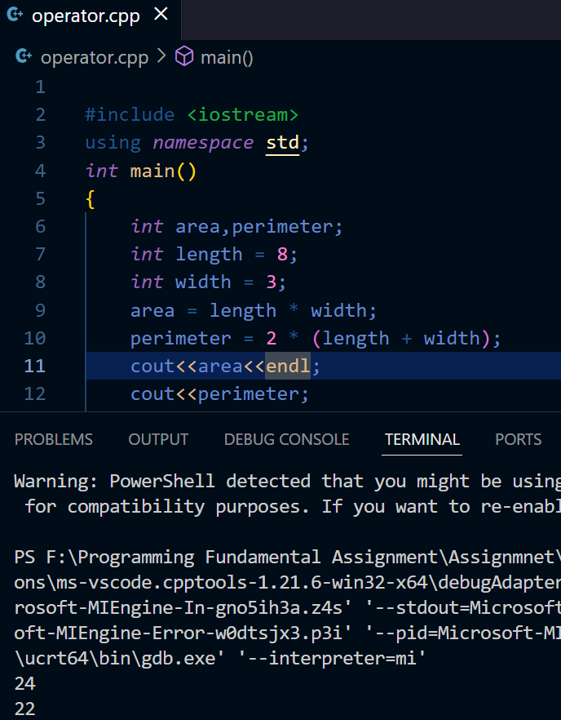
Lab 3.3  Lab 3.4 | Create a new project and copy the following code in the code editor, run and compile the code and observe the output. Write down the output that appears on the screen in the space given below:  #include <iostream>  using namespace std;  int main()  {  int a,b,x,y;  a=b=x=y=0;  ++a;  b=a;  x++;  y=x;  cout << "a = " << a << endl;  cout << "b = " << b << endl;  cout << "x = " << x << endl;  cout << "y = " << y << endl;  return 0;  }  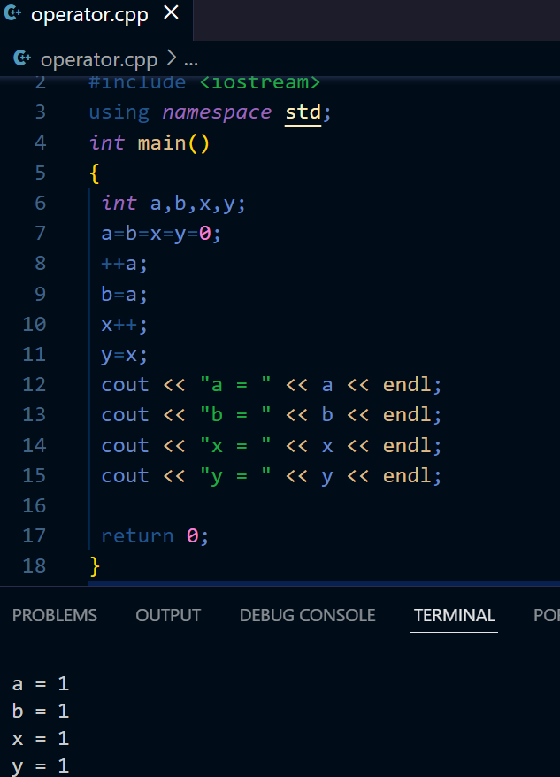  Create a new project and copy the following code in the code editor, run and compile the code and observe the output. Write down the output that appears on the screen in the space given below:  #include <iostream>  using namespace std;  int main()  {  int a,b,x,y;  a=b=x=y=0;  b=++a;  Y=x++;  cout << "a = " << a << endl;  cout << "b = " << b << endl;  cout << "x = " << x << endl;  cout << "y = " << y << endl;  return 0;  }  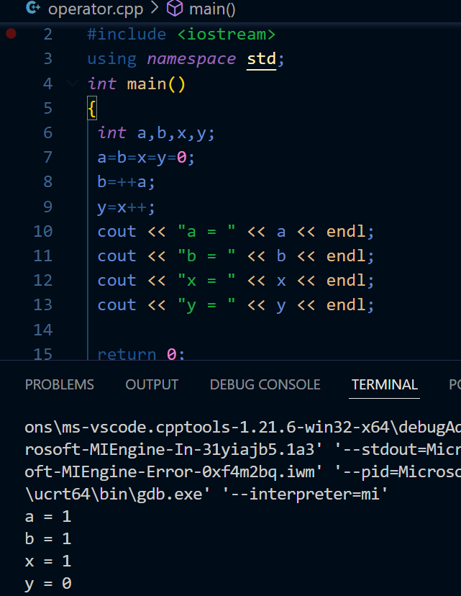
Lab 3.5 LAB TASKS

1: Use the code of Lab3.4 and modify it according to the below instructions.
- Make new variables c and z.
- Assign value 1 to variable c.
- Postfix decrement variable a.
- Assign the value of variable a to c in the same line of code.
- Print values of variables a and c.
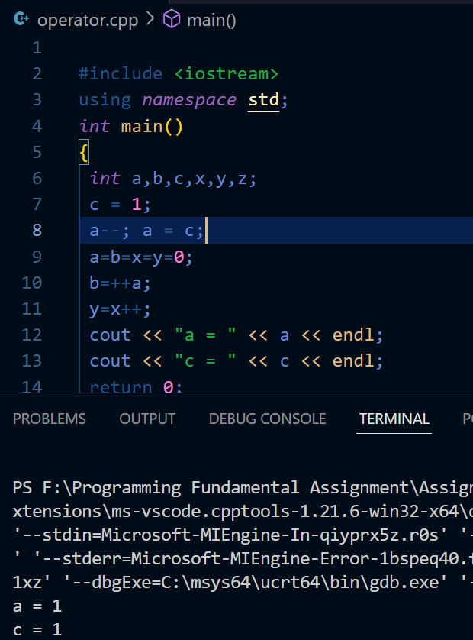

2: Write a program to take temperature in Fahrenheit as float and set its value to 70 i.e. (float Fahrenheit = 70) and convert it into Centigrade. Display output as:

The temperature in Fahrenheit is 70
Temperature in Celsius is 21.11

